**Front-end web**

**Development.**

**css**

**Selectors, elements and classes.**

* **(name of element{}) Element selector =** everything within the curly brackets will have the effect applied to.
* **(# name of element{}) Id selector =** unique within the page. Used to select one unique element.
* **(. Class name{}) Class selector=** html elements with specific class attributes.
* **(name of element . class name{}) Only specific element to be affected by the class =** specifying which element in a class should be affected. E.g. if you have <p> and <h1> which both share the same class, but you want only <p> to be affected, you then put p.name of class{}
* **(class-one class-two{}) Two classes =** elements can be in more than one class. This will impact the element in both ways for the class. To do this put a space between the elements on the html document.
* **(*{}) Universal selector =**  this affects the whole html elements
* **(html1, html2, html3,{}) =** this is used so that you don’t have to do each html element separately.

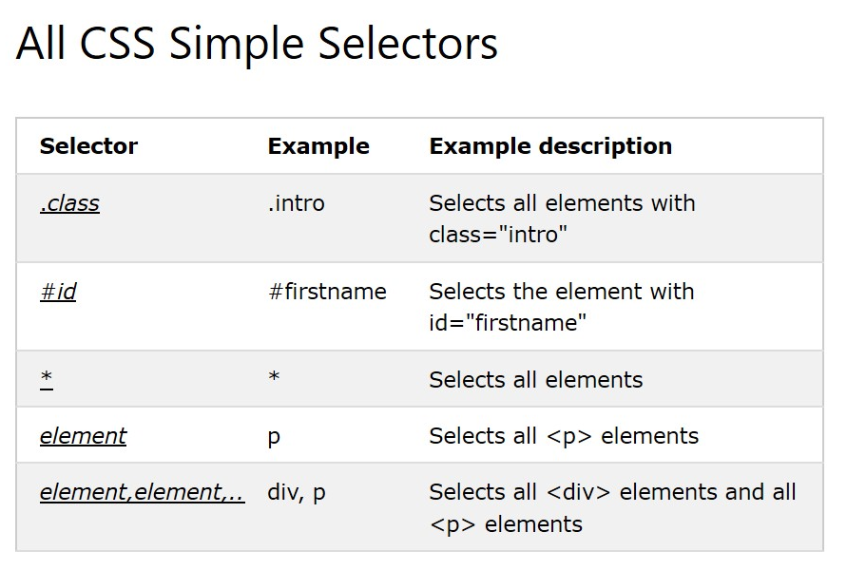

* **There shouldn’t be a space between a property value and the unit( e.g margin-left:20 px is wrong. margin-left: 20px is right. This is because there isnt a space between the 20 and the px**

**Inserting CSS**

* **External CSS=** used for all pages or most of the pages in the website.
  + - **<link rel=”stylesheet” type= “text/css” href=”mystyle.css”>**
    - This should not include any html tags.
    - Must be saved with .css at the end
* **Internal CSS=** used if one single html page has a unique style.
  + - **<style> element inside the <head> of the html page**
* **Inline CSS=** used to apply a unique style to a single element.
  + - **<h1 style= “color red;”> This is a paragraph </p>**
    - loses many advantages of a style sheet (by mixing content with presentation).
    - Do not use this method a lot.
* **Multiple style sheets=** the last element will be used.
* **Cascading order=**

1. Inline style (inside an HTML element)
2. External and internal style sheets (in the head section)
3. Browser default

**Colors**

* **CSS color names =** type a color name e.g gray or white
* **Color background=**

<h1 style=”background-color: red;”> Hello world!</p>

* **Color border=**

<h1 style=”border: 2px solid blue;”> Hello world</h1>

* **RGBA value= rgb (red, green, blue, alpha)**
* rgba( 255, 30, 4, 0.5)
* 255 is the maximum
* Alpha is for transparency and is between 0 and 1.
* Opaque white (255,255,255, 1.0)
* Very transparent white(255,255,255, 0.1)
* Gray (any number but all three values are the same)
* Half transparent black (0, 0, 0,0.5)
* **HSLA value= hsla(hue, saturation, lightness, alpha)**
* Hue= colour from 0 to 360. 0 = red, 120 = green, 240 = blue
* Saturation = percentage. 0 = black and white, 100% = full color
* Lightness = percentage. 0%= black, white is 100%
* Alpha is for transparency and is between 0 and 1.
* hsl (number, percentage %, percentage %, number)

**Colors background**

* **background color =** shows the colour for each element. Each <div> or <p> or <h1> can have its own background color
* **background-image=** makes an image for each element of the html file when specified. The image is automatically repeated to fill the element.
* **Background-repeat=** images are automatically repeated vertically and horizontally. In order to make repetition just:
* Horizontally (x-axis) = background-repeat: repeat-x
* Vertically (y-axis) = background-repeat: repeat-y
* No repeat= background-repeat: no-repeat;
* **background-position=** moves the position of the background image with regards to text or another div.
* background-position: top right
* background-position left top
* background-position: bottom left
* background-position: bottom right
* **background-scrolling=** to make the image in one place on the page or for the image to stay in the same position while scrolling so it can still be seen.
* **Picture continues on the screen while scrolling:** Background-attachment: fixed;
* **Picture doesn’t show once it is scrolled past:** background-attachment: scroll;
* No repeat= background-repeat: no-repeat;
* **background-clip:** to show where part of the background will be painted.
* **Inside border of background:** background-clip: border-box;
* **Touching the edge of the box:** background-clip: padding-box;
* **Outside the box:** background-clip: content-box

**Border**

* **Border-style:** what type of border is displayed:
* **Dotted**
* **Dashed**
* **Solid**
* **Double**
* **Groove** – 3D grooved boarder. The effect depends on the border-color value.
* **Ridge** – Defines a 3D ridged border. The effect depends on the border-color value.
* **Inset** - Defines a 3D outset border. The effect depends on the border-color value.
* **Outset** - Defines a 3D outset border. The effect depends on the border-color value.
* **None** - defines no border.
* **Hidden** - Defines a hidden border.
* **Mix** – more than one border style.

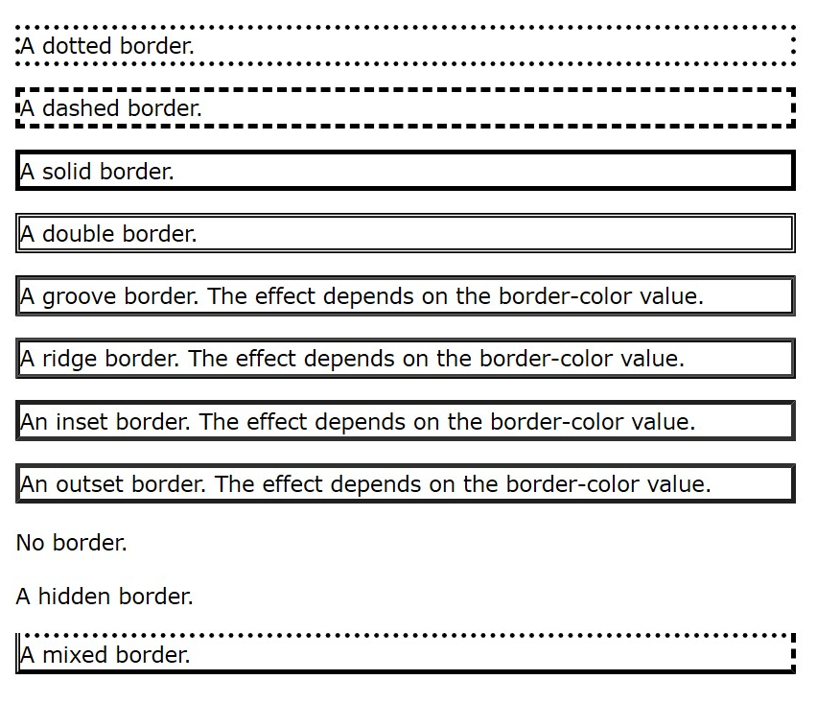

* **Border-width:** (top border, right border, bottom border and left border)
  + Specific sizes of border-width: (in, px, pt, cm, em, ect)
  + General border-width values: thin, medium, thick
* **Border-color:** border-color: red green blue yellow;

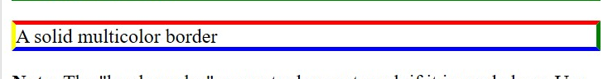

* **individual borders:**

p {  
  border-top-style: dotted;  
  border-right-style: solid;  
  border-bottom-style: dotted;  
  border-left-style: solid;  
}

* **border-radius:**
  + - square = 0px
    - curved edges = 5px
    - the higher the px number, the more the curved edges are.

**Margin**

**(four values)** Margin: top right bottom left

**(three values)** Margin: top right & left bottom

**(Two values)** Margin: top &bottom right & left

**(one value)** Margin: all four margins are the same

* **auto =** the browser calculates the equally for left and right.
* **length =** specifies a margin in px, pt, cm, ect.
* **% =** specifies a margin in the percentage of the width of the containing element
* **Inherit =** margin should be inherited from the parent element

**Margin collapse:** top and bottom margins of elements are sometimes collapsed into a single margin that is equal to the largest of the two margins. This does not happen on left and right margins! Only on top and bottom margins.

**Padding**

**Padding 4 values: top right bottom left;**

**Padding 3 values: top right & left bottom;**

**Padding 2 values: top & bottom right & left**

**Padding 1 value: all sides the same**

* Gives spaces around the things inside the element. Given in px, pt, cm, % or inherited from parent element.
* Cant have negatives
  + - **padding-top: 50px;**
    - **padding-right: 30px;**
    - **padding-bottom: 60px;**
    - **padding-left: 20px;**
    - **or padding: 50px 30px 60px 20px;**
* **box-sizing =** used to make sure content does not go out of sync with padding from other elements. Eg padding on element one may be 30px and padding on element two may also be 30px. However due to there being more writing in element two, the padding becomes wider than element two.

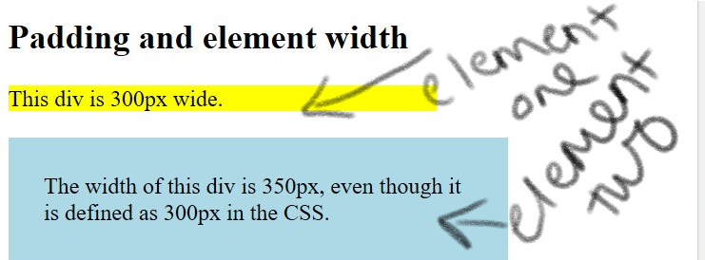

Using a box-border stop this and creates this:

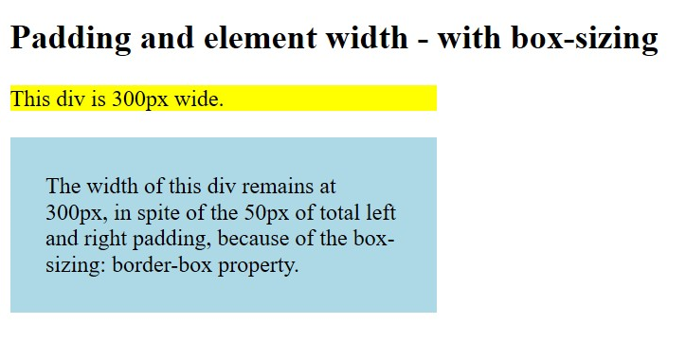

This is done by putting:

box-sizing: border-box;

**Height and Width**

This is not inclusive of padding, borders or margins.

**Height** and **width** can have the following values:

* auto – this is default. The browser calculates the height and width
* length – defines the height/ width in px, cm ect.
* %- defines the height/ width in percent of the containing block
* Initial – sets the height/ width to its default value
* Inherit- the height/ width will be inherited from its parent value

Height: 100px;

Width: 50%;

**max-width:** used to set the maximum width of an element.

* can be used to be specified in px, cm, ect, percentage of containing block or none (default)

**CSS Box Model**

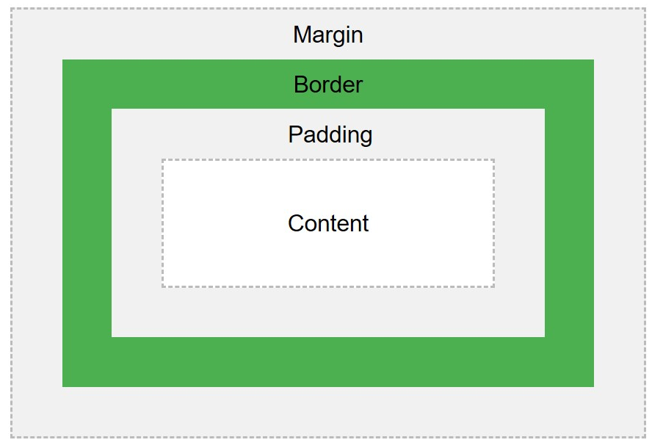

**Content =** where text and images appear

**Padding =** clears an area around the content. Padding is transparent

**Border =** a border that goes around the padding and content

**Margin =** clears an area outside the border. The margin is transparent.

Box model calculations

**Total element width**

= width + left padding + right padding + left border + right border + left margin + right margin

**Total element height**

= height + top padding + bottom padding + top border + bottom border + top margin + bottom margin

**Beyond the border there is an outline.**

* Outlines can have the same styles as borders

**Text Alignment**

* Aligns to the horizon.
* Can take values: center, left, right and justify.
* Justify means the each line is stretched to have equal width like a newspaper.

**Text decoration:**

Used to give wording lines above, below, through or taken away from words.

______

* (Example) = text-decoration: overline;
* (~~Example~~) = text- decoration: line-through;
* (Example)= text-decoration: underline;
* (Example link)= text-decoration: none;

**Text transformation**

* used to say if the letters are uppercase or lowercase.
* Values given can be: uppercase, lowercase or capitalize.

e.g

p{

text-transform: upper;

}

**Text indentation**

Text indentation is used to specify the indentation of the first line of text.

e.g

p{

text-indent: 50px;

}

**Letter spacing :** how far away each letter is from the other.

e.g

p{

letter-spacing: 3px;

}

h1{

letter-spacing: -30px

}

**Text shadow**

Adds shadow to text.

Text-shadow: horizontal shadowpx vertical shadowpx color of the shadow

e.g

p{

text-shadow: 3px 2px red;

**CSS Fonts**

**Font family =** like font on word e.g arial or times roman

**Font style=** mostly used to specify where to put italic words. Can be normal, italic or oblique (similar to italic but less supported)

e.g: p{

font-style: normal;

}

**Font size:** can be absolute or relative. Default size of fonts are 16px or 1em. If using px for font sizing, the zoom tool can still be used to resize the entire page. Em is the best for accessibility.

Pixels/16=em

The best solution for all browsers is to do font-size: 100% in the body and the rest of the elements in em.

e.g

body {  
  font-size: 100%;  
}  
  
h1 {  
  font-size: 2.5em;  
}  
  
h2 {  
  font-size: 1.875em;  
}  
  
p {  
  font-size: 0.875em;  
}

**Absolute:**

* Sets text to a specific size
* Does not allow a user to change the text size in all browsers
* Useful when physical size of the output is known

**Relative:**

* Relative sets the size relative to the surrounding elements
* Allows a user to change the text size in browser

**Font Weight**

* Can be normal or bold

e.g

p{

font-weight: bold;

}

**Responsive Font size:**

* This allows the text to change size according the the browser it is being viewed on.
* This is measured in viewport widths.
* 1vw=1% of the viewport width

e.g

p{

style=”font-size:10vw”> Hello World</h1>

**Icons**

* Font Awesome has a library of icons
* <https://fontawesome.com/>
* Add the name of the specified icon class to any inline HTML element like <i> or <span>
* Add either of these 3 in the head section of the html:

**1)** <script src="https://kit.fontawesome.com/yourcode.js"></script>

**2)** <link rel="stylesheet" href="https://maxcdn.bootstrapcdn.com/bootstrap/3.3.7/css/bootstrap.min.css">

**3)** <link rel="stylesheet"href="https://fonts.googleapis.com/icon?family=Material+Icons">

**Links**

e.g

p{ a: link}

Must be put in the order of :

P {a: link} (this is the actual link which is unvisited)

a: visited (this is when the link has already been clicked on before)

a: hover (when the mouse is over the link)

a: active (a link the moment it is clicked)

* Links can be used with many other styles

**Ordered and unordered lists**

e.g

ol.p{

list-style-type: circle}

or

e.g

ul.p{

list-style-tupe: lower-alpha

Ordered <ol> lists use numbers or letters

Unordered <ul> lists use bullet points

For pictures as the list marker use :

ul{

list-style-image: url(“source.of.photo”);

list-style-position is used to specify the position of the list’s markers. Inside or outside a box.

This can be either be:

* Inside
* outside

e.g

ul.a{

list-style-position: outside;

}

In order to have a list, there will be a default setting with a margin and padding. In order to get rid of this put the margin as 0 and the padding as 0.

* If you don’t want a marker for the bullet point do

ul{

list-style-type: none;

}

Use

ul{

**list-style:** square inside url ([www.pic.com](http://www.pic.com))

}

In order to get the short hand for all unordered lists. The values for the list has to be in this order:

1. List-style-type (if the list-style-image cannot work this will work instead. For this value you can put shapes e.g circle, square or arrow.)
2. List-style-position (inside or outside of the content flow)
3. List-style-image (put the url of the image)

To decorate the individual list items **not including the marker us li**:

e.g:

ul li{

background: green;

}

**Tables**

Tables in html use

<table>

<th>

And

<td>

The border of tables in css is controlled doing

E.g

Table, th, td{

Border: 1px solid black;

}

* Border collapse = border with only lines use border-collapse;
* If you don’t want the table to have lines on the inside and only on the border use

e.g

table {

border: 1px solid black;

}

* <td> is a standard cell.
* <th> is the header of the table.
* Text-align: left, right or centre
* Vertical-alignment: bottom, top or centre /*this will show if the text is in the centre, at the bottom or top of each cell.
* Use border-bottom: 1px solid black this will show horizontal dividers
* For striped tables use e.g

tr: nth-child (even) { background color: grey}

* <div style=”overflow-x: auto”> is used to have a responsive table with a side ways scroll

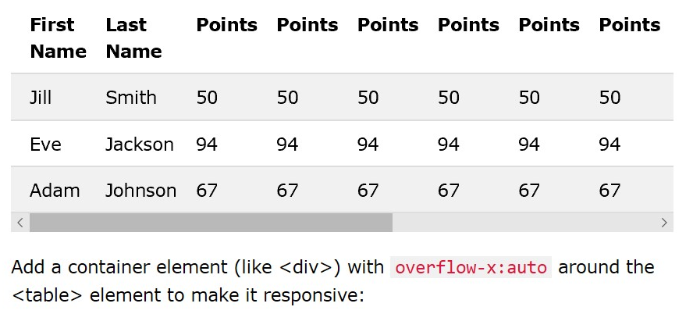

**Display**

* Controls layout
* Default display value for html elements are normally block or inline
* Block-level elements always starts on a new line and uses the whole width avalible.

Block-level elements can be:

* + Div
  + H1
  + P
  + Form
  + Header
  + Footer
  + Section
* Inline elements do not start on a new line, they only take up as much as needed.

Inline elements can be:

* + Span
  + A
  + Img
* Display: none; is used to hide and show elements and is normally used with javascript without deleting and recreating them. For example:

This

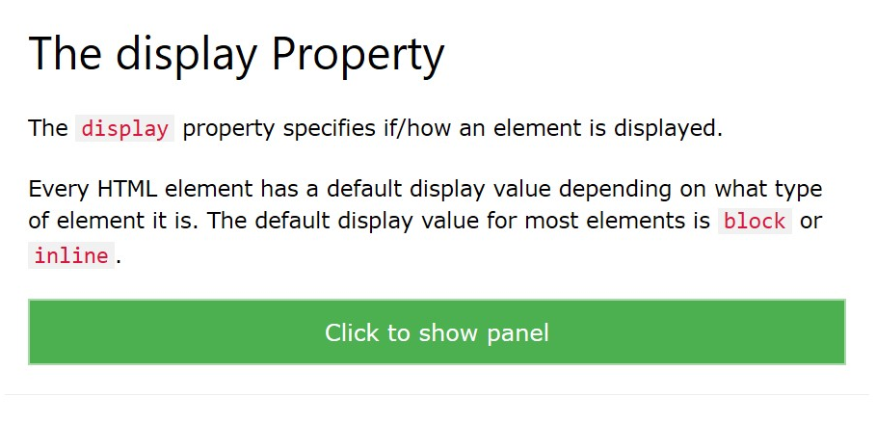

Turns into this:

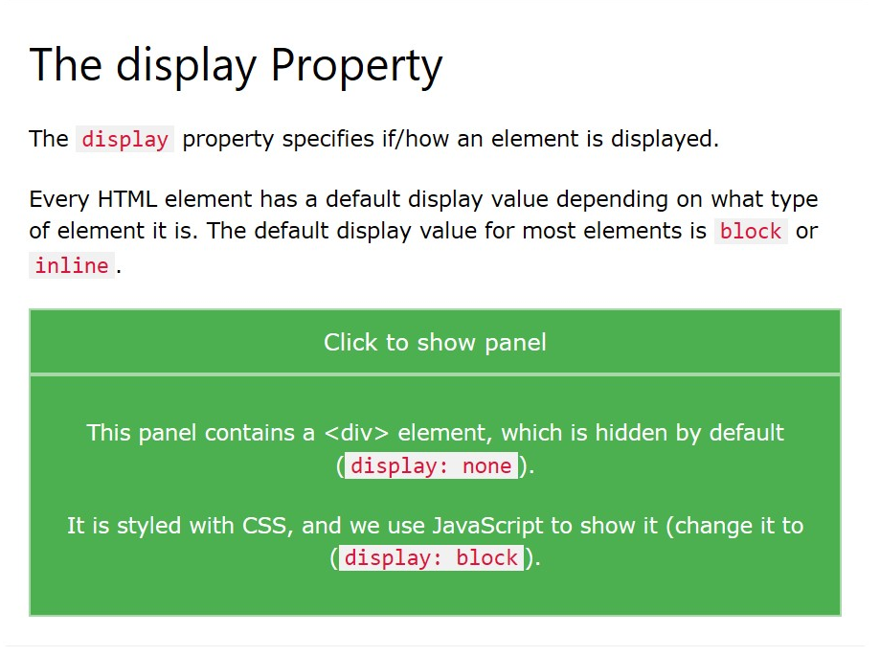

Overriding the default display can be done by putting the display value to the opposite.

e.g a list normally goes down.

Instead you can do this horizontally. E.g

li{

display: inline;

}

* To hide an element: put display: none;
* Visibility: hidden; does the same thing but the space where the item was before hiding it would still be there. Almost making the item completely transparent

**Layout width and max-width**

Use

Max-width so that everything in the element can be seen even if the browser is smaller than the maximum px

**position**

specifies the type of positioning method used for the html element.

The five position values are:

1. Static
2. Relative
3. Fixed
4. Absolute
5. Sticky

* **Static** is the default for html. It is positioned according to the flow of the page. It is not affected by top, bottom, left or right.
* **Relative** is positioned relative to its normal position. Setting the top, right, bottom, and left properties of a relatively-positioned element will cause it to be adjusted away from its normal position. Other content will not be adjusted to fit into any gap left by the element.
* **Fixed** is positioned relative to the viewport. It stays in the same place on the screen even if you start scrolling. Top, right, bottom and left are used to position fixed elements.
* **Absolute** is positioned relative to the closest relative ancestor.
* **Sticky** is used based on the users scoller. For example headers and footers that can always be seen when scrolling on a web page.

When positioning elements, sometimes one can go over the over, this can be controlled using the z-index.

* **z-index** can be used to control which overlapping element goes on top. The z-index needs to be either + or - . the negetive value goes behind, the positive goes infront. The element with the highest number will be at the front.
  + if this is not specified the element listen last on the html sheet will be on top.
  + To add text ontop of an image use:

**<div class=”topleft”> words</div>**

**Layout overflow**

* This controls what will happen to content when it is too big to fit into an area
* This can clip the content or add scroll bars to the specified area

Overflow has four values:

1. Visible – this is the default. The overflow is not clipped and the content renders outside the elements box.
2. Hidden – this means the overflow is clipped and the rest of the content will be invisible
3. Scroll – the overflow is clipped, and a scrollbar is added to see the rest of the content
4. Auto- this only adds scrollbars when necessary
   * Overflow only works for block elements with a specified height

Overflow: allows control over what happens when content overflows outside of a box.

Overflow can be hidden or visible or scroll or auto.

Over flow-x – specifies what to do with the left / right edges of the content.

Over-flow y specifies what to do with the top bottom edges

**Float**

* + Floats tell the html how the element should float
  + Clears / clear shows what element can float next to a clear element and on which side.
  + It’s the css equivalent to wrap on word

Floats can have one of four values:

* Left
* Right
* None (default)
* Inherit

Clear can have one of five values:

* None – floats **CAN** go on both sides
* Left- no float on the left side
* Right- no float on the right side
* Both - no floating element on either side
* Inherit – inherited from parent

Clears should match the value that was given for the float.

Overflow: auto should be used on a clear in order to resize an element to make both fit. Sometimes this might show scroll bars. In order to avoid this, use:

.clearfix::after {  
  content: "";  
  clear: both;  
  display: table;  
}

**Grid of Boxes/ Equal Width Boxes**

**\* {**

**box-sizing: border-box;**

**}**

**.box {**

**float: left;**

**width: 33.33%;**

**padding: 50px;**

**}**

**.clearfix::after {**

**content: "";**

**clear: both;**

**display: table;**

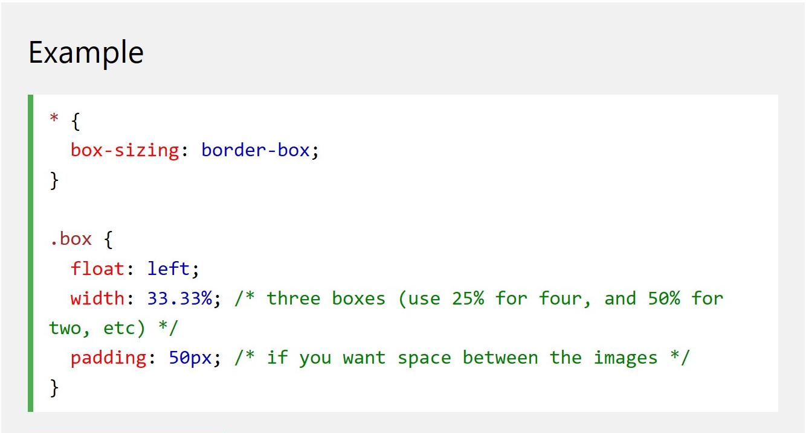

Use

.box{

Height: 500px;

}

If you want to float two boxes that have the same height

Use floats for a navigation bar. Then you display.

Inline-block value

* Display: inline-block is used to set a width and height on the element with respected margin. Display: inline does not do this
* Display: inline-block doesn’t add a line break after the element; therefore the element can sit next to the other element. If you want a line break use display: block
* Inline-blocks can be used for navigation links.
* Inline blocks are used to display boxes next to each other.

Horizontal and vertical align

To centre a image do:

Img{

Display: block;

Margin-left: auto;

Margin-right: auto;

Absolute element can be used to position elements. Absolute positioned elements are removed from the normal flow and can overlap elements

Floats can also be used to position elements. E.g float: right;

Transform can also be used to centre elements. Transform: translate(-50%, -50%)

**Combinators**

Combinators explain the relationship between the selectors

Combinators can be put between two + simple selectors.

There are four types of different combinators in CSS:

* Descendant selector (space)
* Child selector (>)
* Adjacent sibling selector (+)
* General sibling selector (~)

Descendant selector (space) – matches all the elements that are descendants of the chosen element

Child selector (>) – selects all the elements that are children of the element

Adjacent sibling selector (+) – selects all elements that are the adjacent sibling of a specified element. Immediately following siblings

General Sibling Selector (~) – selects all elements that are siblings of a specified element.

Pseudo-classes

These can be used to:

* Style an element when the user’s mouse is over it
* Style visited and unvisited links differently
* Style an element when it gets focus

selector:pseudo-class {  
  property:value;  
}

MUST BE DONE IN THIS ORDER

a:link = the original link

a:visited = when the link has been visited

a:hover = when mouse is over the link

a:active = when youre on the link

HOVER OVER SOMETHING TO REVEAL SOMETHING ELSE:

p {  
  display: none;  
  background-color: yellow;  
  padding: 20px;  
}  
  
div:hover p {  
  display: block;  
}

:first-child{ = specifies the elements that is the first child of another element

**MATCH ALL <i> ELEMENTS IN ALL <p>**

p i:first-child {  
  color: blue;  
}

**MATCHES ALL <i> ELEMENTS IN THE FIRST CHILD <p> ELEMENTS**

p:first-child i {  
  color: blue;  
}

**The :lang pseudo-class**

Define special rules for different languages

**Pseudo-Elements**

Styles specified parts of an element

Can be used to style the first letter or line of an element

Can be used to insert content before or after the content of an element.

selector::pseudo-element {  
  property:value;  
}

:: is used in CSS3. This distinguishes between pseudo-classes and pseudo-elements.

::first-line

* Can only be applied to block-level elements
* Can be used for:
  + Font
  + Color
  + Background
  + Word-spacing
  + Letter
  + Text decoration
  + Vertical-align
  + Text-transform
  + Line-height
  + Clear

::first-letter

* Font
* Color
* Background
* Margin
* Passing
* Border
* Text-decoration
* Vertical-align
* Text-transform
* Line-height
* Float
* Clear

Classes and psedo elements can be combined.

Several pseudo elements can be combined

::before = content before the psedo element

:: after = contrent after the psedo-element

::selection = matches the portion of an element that is selected by the user. For this color, background, cursor and outline can be used.

**CSS Opacity/ Transparency**

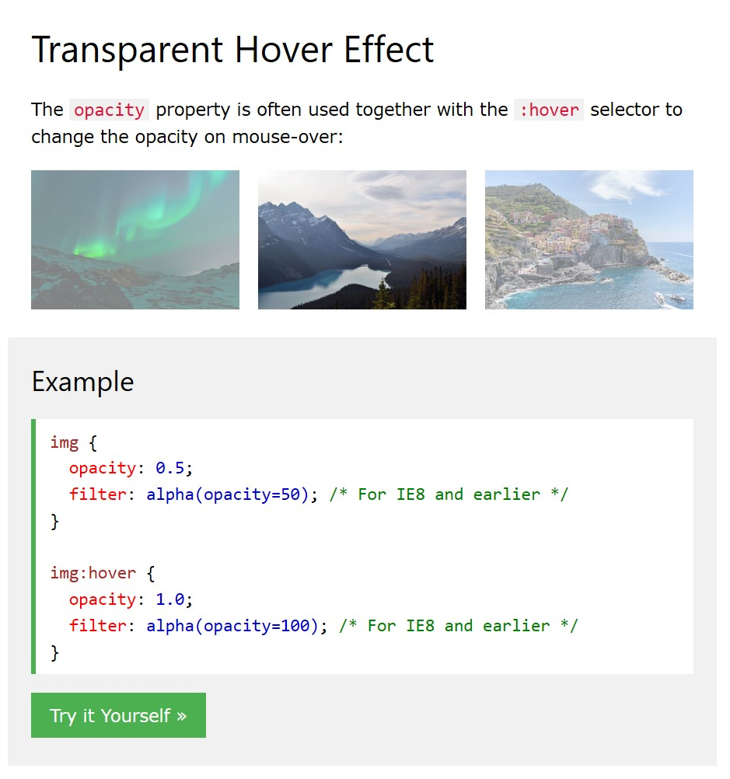

Opacity can be used to make the background of an element transparent.

RGBA can be used to make the background of child element transparent.

**NAVIGATION**

Use <ul> then <Li><a> inside

Then get rid of the marker for the bullet points

Put margin to 0 and padding to 0

Vertical

li a {  
  display: block;  
  width: 60px;  
}

horizontal – need to use inline or floating

li {  
  display: inline;  
}

sticky navigation bar=

ul {  
  position: -webkit-sticky; /* Safari */  
  position: sticky;  
  top: 0;  
}

Dropdowns

**HTML)** Use any element to open the dropdown content, e.g. a <span>, or a <button> element.

Use a container element (like <div>) to create the dropdown content and add whatever you want inside of it.

Wrap a <div> element around the elements to position the dropdown content correctly with CSS.

**CSS)** The .dropdown class uses position:relative, which is needed when we want the dropdown content to be placed right below the dropdown button (using position:absolute).

The .dropdown-content class holds the actual dropdown content. It is hidden by default, and will be displayed on hover (see below). Note the min-width is set to 160px. Feel free to change this. **Tip:** If you want the width of the dropdown content to be as wide as the dropdown button, set the width to 100% (and overflow:auto to enable scroll on small screens).

Instead of using a border, we have used the CSS box-shadow property to make the dropdown menu look like a "card".

The :hover selector is used to show the dropdown menu when the user moves the mouse over the dropdown button.

Right dropdown:

.dropdown-content {  
  right: 0;  
}

Look at image sprites again to understand multiple images in one page.

**CSS Attributes Selectors**

Style CSS with specific attributes

[attribute] selects elements with a specified attribute

a[target] {  
  background-color: yellow;  
}

this means all <a> elements with a target attribute

[attribute=”value”] this selects element with a specified attribute and value.

[attribute~=”value”] selects elements with an attribute value containing a specific word

[attribute|="value"] is used to select element with athe specified attribute starting with the specified value.

[attribute^="value"] used to select elements whose attribute value begins with a specified value

[attribute$="value"] selector is used to select elements whose attribute value ends with a specified value.

[attribute*="value"] selector is used to select elements whose attribute value contains a specified value.

The attribute selectors can be useful for styling forms without class or ID

Forms

f you only want to style a specific input type, you can use attribute selectors:

* input[type=text] - will only select text fields
* input[type=password] - will only select password fields
* input[type=number] - will only select number fields
* etc..

use:

- border-radius for rounded edges

- border-bottom is used for only a bottom line to fill in name

- :focus is used to change colour when box is selected e.g.

input[type=text]:focus {  
  background-color: lightblue;  
}

or

input[type=text]:focus {  
  border: 3px solid #555;  
}

or

input[type=text] {  
  background-color: white;  
  background-image: url('searchicon.png');  
  background-position: 10px 10px;   
  background-repeat: no-repeat;  
  padding-left: 40px;  
}

prevent text boxes from resizing using :

resize:none;

select menus go down

counters

counters change their position based on the amount of times they have been clicked.

CSS counters are like "variables". The variable values can be incremented by CSS rules (which will track how many times they are used).

To work with CSS counters we will use the following properties:

* counter-reset - Creates or resets a counter
* counter-increment - Increments a counter value
* content - Inserts generated content
* counter() or counters() function - Adds the value of a counter to an element

To use a CSS counter, it must first be created with counter-reset.

body {  
  counter-reset: section;  
}  
  
h2::before {  
  counter-increment: section;  
  content: "Section " counter(section) ": ";  
}

nesting counters

body {  
  counter-reset: section;  
}  
  
h1 {  
  counter-reset: subsection;  
}  
  
h1::before {  
  counter-increment: section;  
  content: "Section " counter(section) ". ";  
}  
  
h2::before {  
  counter-increment: subsection;  
  content: counter(section) "." counter(subsection) " ";  
}

revisit counters

units

|  |  |
| --- | --- |
| **Unit** | **Description** |
| cm | centimeters [Try it](https://www.w3schools.com/cssref/tryit.asp?filename=trycss_unit_cm) |
| mm | millimeters [Try it](https://www.w3schools.com/cssref/tryit.asp?filename=trycss_unit_mm) |
| in | inches (1in = 96px = 2.54cm) [Try it](https://www.w3schools.com/cssref/tryit.asp?filename=trycss_unit_in) |
| px * | pixels (1px = 1/96th of 1in) [Try it](https://www.w3schools.com/cssref/tryit.asp?filename=trycss_unit_px) |
| pt | points (1pt = 1/72 of 1in) [Try it](https://www.w3schools.com/cssref/tryit.asp?filename=trycss_unit_pt) |
| pc | picas (1pc = 12 pt) |

|  |  |  |
| --- | --- | --- |
| **Unit** | **Description** |  |
| em | Relative to the font-size of the element (2em means 2 times the size of the current font) | [Try it](https://www.w3schools.com/cssref/tryit.asp?filename=trycss_unit_em) |
| ex | Relative to the x-height of the current font (rarely used) | [Try it](https://www.w3schools.com/cssref/tryit.asp?filename=trycss_unit_ex) |
| ch | Relative to width of the "0" (zero) | [Try it](https://www.w3schools.com/cssref/tryit.asp?filename=trycss_unit_ch) |
| rem | Relative to font-size of the root element | [Try it](https://www.w3schools.com/cssref/tryit.asp?filename=trycss_unit_rem) |
| vw | Relative to 1% of the width of the viewport* | [Try it](https://www.w3schools.com/cssref/tryit.asp?filename=trycss_unit_vw) |
| vh | Relative to 1% of the height of the viewport* | [Try it](https://www.w3schools.com/cssref/tryit.asp?filename=trycss_unit_vh) |
| vmin | Relative to 1% of viewport's* smaller dimension | [Try it](https://www.w3schools.com/cssref/tryit.asp?filename=trycss_unit_vmin) |
| vmax | Relative to 1% of viewport's* larger dimension | [Try it](https://www.w3schools.com/cssref/tryit.asp?filename=trycss_unit_vmax) |
| % | Relative to the parent element |  |

Browser Support

The numbers in the table specify the first browser version that fully supports the length unit.

|  |  |  |  |  |  |
| --- | --- | --- | --- | --- | --- |
| Length Unit | chrome | Internet explorer | firefox | safari | Red circle? |
| em, ex, %, px, cm, mm, in, pt, pc | 1.0 | 3.0 | 1.0 | 1.0 | 3.5 |
| ch | 27.0 | 9.0 | 1.0 | 7.0 | 20.0 |
| rem | 4.0 | 9.0 | 3.6 | 4.1 | 11.6 |
| vh, vw | 20.0 | 9.0 | 19.0 | 6.0 | 20.0 |
| vmin | 20.0 | 9.0* | 19.0 | 6.0 | 20.0 |
| vmax | 26.0 | Not supported | 19.0 | 7.0 | 20.0 |

**Note:** Internet Explorer 9 supports vmin with the non-standard name: vm.

There are four categories which define the specificity level of a selector:

**Inline styles** - An inline style is attached directly to the element to be styled. Example: <h1 style="color: #ffffff;">.

**IDs** - An ID is a unique identifier for the page elements, such as #navbar.

**Classes, attributes and pseudo-classes** - This category includes .classes, [attributes] and pseudo-classes such as :hover, :focus etc.

**Elements and pseudo-elements** - This category includes element names and pseudo-elements, such as h1, div, :before and :after.

How to Calculate Specificity?

Memorize how to calculate specificity!

Start at 0, add 1000 for style attribute, add 100 for each ID, add 10 for each attribute, class or pseudo-class, add 1 for each element name or pseudo-element.

**ID selectors have a higher specificity than attribute selectors** - Look at the following three code lines:

### **Example**

div#a {background-color: green;}  
#a {background-color: yellow;}  
div[id=a] {background-color: blue;}

[Try it Yourself »](https://www.w3schools.com/css/tryit.asp?filename=trycss_specificity2)

the first rule is more specific than the other two, and will be applied.

**Contextual selectors are more specific than a single element selector -** The embedded style sheet is closer to the element to be styled. So in the following situation

### **Example**

**From external CSS file:**  
#content h1 {background-color: red;}  
  
**In HTML file:**  
<style>  
#content h1 {  
  background-color: yellow;  
}  
</style>

the latter rule will be applied.

**A class selector beats any number of element selectors** - a class selector such as .intro beats h1, p, div, etc:

### **Example**

.intro {background-color: yellow;}  
h1 {background-color: red;}

[Try it Yourself »](https://www.w3schools.com/css/tryit.asp?filename=trycss_specificity3)

**The universal selector and inherited values have a specificity of 0** - *, body * and similar have a zero specificity. Inherited values also have a specificity of 0.

Notes from Exercises:

* to style an id put # then the id name.

**ADVANCED**

**Rounded borders = border-radius.**

The higher the border-radius the more the curve of the corners

**Tip:** The border-radius property is actually a shorthand property for the border-top-left-radius, border-top-right-radius, border-bottom-right-radius and border-bottom-left-radius properties.

**Border images**

* **Used to set an image as the border**
* **There are 3 parts to the border-image property:** 
  + **1) The image to use as the border**
  + **2) Where to slice the image**
  + **3) Define where the middle section should be repeated (round) or stretched.**

**To have the image repeated use:**

**Border-image: url(jlkfdsajlfjd) where to slice the image round**

**Border-image and different slice values**

* **Changing the value of where to slice the image will completely change the look of the border.**

**CSS Multiple background**

**Use commas behind background-image: url(dsfafdsa), url(fadfasf).**

**Shorthand**

**Background: url(indkljajf) right bottom no-repeat, url(jdsakjfla) le top repeat.**

**Contain**

**Background-size:**

**Horizontal and vertical or contain (makes the image as big as the container but doesn’t stretch the image and once one element touches the border the rest of it is at scale) or cover (scales the image so that the content area is completely covered by the background image).**

**To have a background image that fills the entire page of the website there are four requirments:**

* **Fill the entire page with the image (no white space)**
* **Scale image as needed**
* **Centre image on page**
* **Do not cause scrollbars**

**e.g**

**html {**

**background: url(img_man.jpg) no-repeat center fixed;**

**background-size: cover;**

**}**

**Hero Image = massive full screen image for web page.**

**Background-origin property**

**Background-origin = where the background image is positioned**

**It takes three different values:**

1. **Border-box- the background image starts from the upper left corner of the border**
2. **Padding-box – (default) the background image starts from the upper left corner of the padding edge**
3. **Content-box – the background image starts from the upper left corner of the content**

**Background-clip = specifies the painting area of the background. This can be 3 different values:**

* **Border-box (default) the background is painted to the outside edge of the border**
* **Border-box- the background is painted to the outside edge of the padding**
* **Content-box- the background is painted within the content box**

**Gradients**

**Two types of gradient:**

* **Linear gradients (go down/ up/ left/ right/ diagonally)**
* **Radial gradient (defined by their center)**

background-image: linear-gradient(direction, color-stop1, color-stop2, ...);

#grad {  
  background-image: linear-gradient(red, yellow);  
}

#left to right grad {  
  background-image: linear-gradient(to right, red , yellow);  
}

#diagonal grad {  
  background-image: linear-gradient(to bottom right, red, yellow);  
}

If you want to define an angle instead:

background-image: linear-gradient(angle, color-stop1, color-stop2);

**this can be used with transparency and repeat:**

#grad {  
  background-image:linear-gradient(to right, rgba(255,0,0,0), rgba(255,0,0,1));  
}

#grad {  
  background-image: repeating-linear-gradient(red, yellow 10%, green 20%);  
}

Radial-gradient for circles

background-image: radial-gradient(shape size at position, start-color, ..., last-color);

#grad {  
  background-image: radial-gradient(red, yellow, green);  
}

Use the defined name of a shape to give it the shape. The default is ellipse.

#grad {  
  background-image: radial-gradient(circle, red, yellow, green);  
}

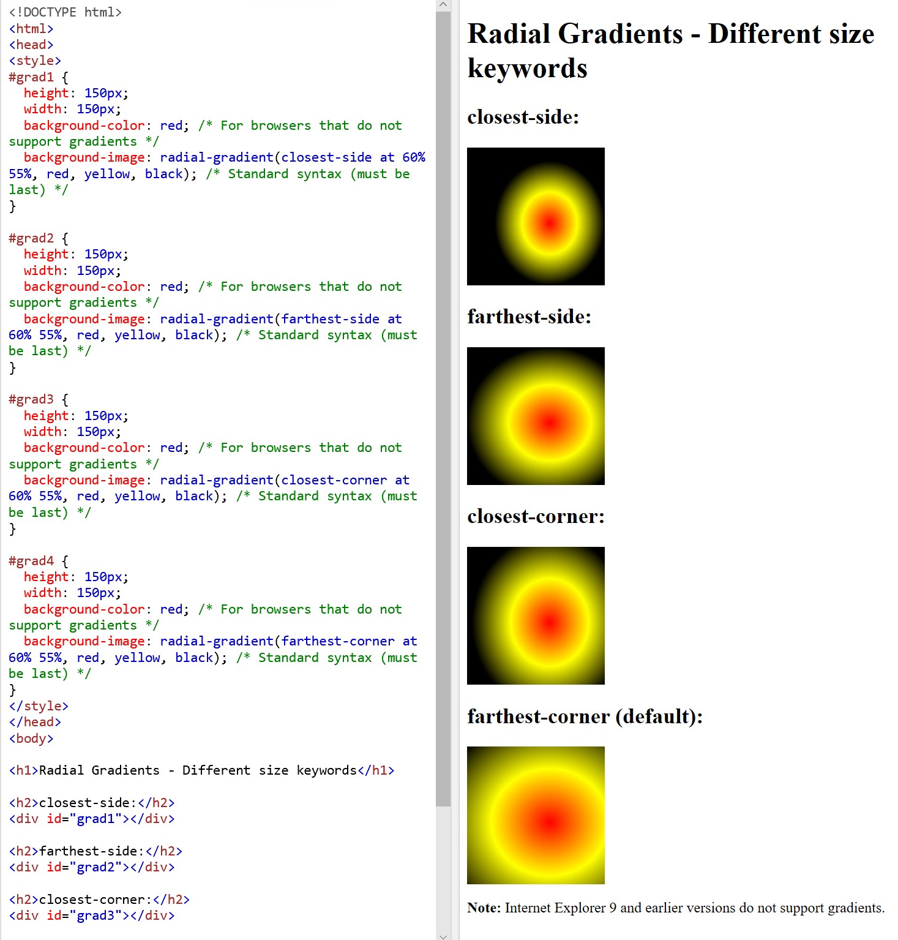

**Shadow Effects**

**There are two types:**

**Text-shadow and box shadow**

**Text-shadow: horizontalpx verticalpx blurpx color;**

**More than one shadow can be used at a time just add a comma between each shadow.**

**Text-shadow: horizontalpx verticalpx blurpx color, 5px 3px 5px blue;**

**Put blur to 0 if you just want a border around the text without blur.**

**Box-shadow property**

**Only specify the horizontal, vertical, blue and color;**

div {  
  box-shadow: 10px 10px 5px grey;  
}

**text effects**

* **Text-overflow= says what to do with text that does not fit in the container.**

Does not show the rest of the text

p.test1 {  
  white-space: nowrap;   
  width: 200px;   
  border: 1px solid #000000;  
  overflow: hidden;  
  text-overflow: clip;   
}

shows … instead of the rest of the text

p.test2 {  
    white-space: nowrap;   
    width: 200px;   
    border: 1px solid #000000;  
    overflow: hidden;  
    text-overflow: ellipsis;   
}

makes overflow text visible when the cursor is over the box the visible text is in.

**div.test:hover {**

**overflow: visible;**

**}**

**Word-wrap = allows long words to be able to be broken and wrap onto the next line.**

p {  
  word-wrap: break-word;  
}

this only breaks where the hyphens are:

**p.test1 {**

**width: 140px;**

**border: 1px solid #000000;**

**word-break: keep-all;**

**}**

**This breaks at any character:**

**p.test2 {**

**width: 140px;**

**border: 1px solid #000000;**

**word-break: break-all;**

**}**

**Writing-mode= shows if text is written out horizontally or vertically.**

p.test1 {  
  writing-mode: horizontal-tb;   
}  
  
span.test2 {  
  writing-mode: vertical-rl;   
}  
  
p.test2 {  
  writing-mode: vertical-rl;   
}

Web fonts

@font-face **= allows the user to use their own font**

**TTF trye type fonts = most common**

**Otf open type fonts = scalable computer fonts.**

**Woff the web open font format = for web page use. Essentially opentype and true type with compression and additional metadata.**

**Woff 2.0 The web open font format= truetype/opentype font that provides better compression than woff 1.0.**

**SVG fonts/ shapes: SVG fonts allow SVG to be used as glyphs when displaying text. The SVG 1.1 specification define a font module that allows the creation of fonts with an SVG document. You can also apply CSS to CVG documents and the @front-face rule can be applied to text in SVG documents.**

**(EOF) Embedded opentype fonts = compact form of opentype. Designed by Microsoft for use as embedded fonts on web pages.**

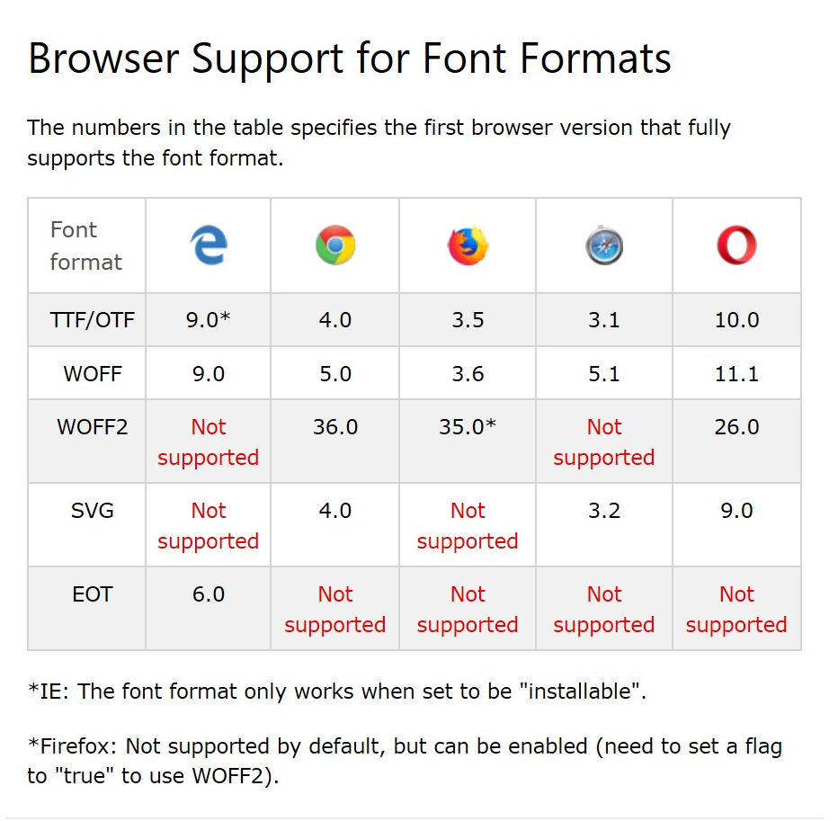

To use the font for an HTML element, refer to the name of the font (myFirstFont) through the font-family property:

@font-face {  
  font-family: myFirstFont;  
  src: url(sansation_light.woff);  
}

div {  
  font-family: myFirstFont;  
}

**use myFirstFont to use your own front:**

**@font-face {**

**font-family: myFirstFont;**

**src: url(sansation_light.woff);**

**}**

**To use bold text add another @font-face rule containing the descripto for bold text:**

@font-face {  
  font-family: myFirstFont;  
  src: url(sansation_bold.woff);  
  font-weight: bold;  
}

2D Transforms

Allows elements to move, rotate, scale and skew elements.

Brower’s that support this is:

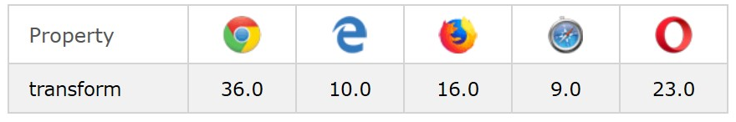

The traform methods that can be used are:

Translate()= moves from current position to where specified by {transform: translate(xpx, ypx);}

Rotate()= moves an element clockwise or counter-clockwise according to the given degree.

{Transform:rotat(20deg);}

Scale(width, height)= increase/ decrease the size of an element

ScaleX(width)= increase width

Scale(height)= increase height

skewX(20deg)= skews along the x asis. This changes a rectangle (See below):

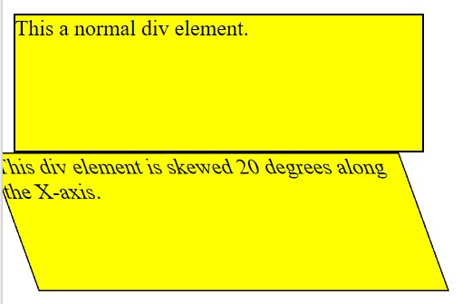

skewY()= from the top to bottom – see below:

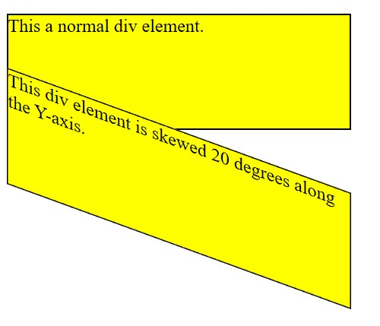

skew() does both horizontal and vertical.

matrix()= div {  
  transform: matrix(1, -0.3, 0, 1, 0, 0);  
}

The parameters are as follow: matrix(scaleX(),skewY(),skewX(),scaleY(),translateX(),translateY())

**3D Transforms**

**Supported by:**

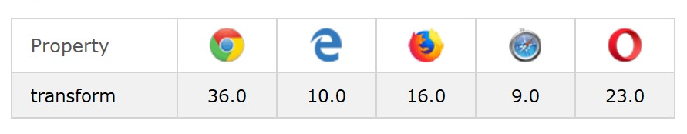

**In older browsers -webkit- is needed as a prefix for the browser to understand the 3D transform properties.**

#myDiv {  
  -webkit-transform: rotateY(130deg); /* Safari prior 9.0 */  
  transform: rotateY(130deg); /* Standard syntax */  
}

To transform you can use:

rotateX()= rotate around the x axis

**totateY()=rotate around the y axis**

**rotateZ()= rota around z axis**

**use degrees (150deg) in the brackets**

**transition allows the person to change the value of an element over a given duration. For all transitions the duration of the effect needs to be stipulated.**

**Transition =** div {  
  transition: width 2s, height 2s, transform 2s;  
}

Shorthand is transition

div {  
  transition: width 2s linear 1s;  
}

**Transition-delay = how long until the transition happens once the mouse is over the div**

**Transition-duration**

**Transition-property**

**Transition-timing-function**

**div {**

**width: 100px;**

**height: 100px;**

**background: red;**

**-webkit-transition: width 2s; /* For Safari 3.1 to 6.0 */**

**transition: width 2s;**

**}**

**div:hover {**

**width: 300px;**

**}**

The transition-timing-function property specifies the speed curve of the transition effect.

The transition-timing-function property can have the following values:

* ease - specifies a transition effect with a slow start, then fast, then end slowly (this is default)
* linear - specifies a transition effect with the same speed from start to end
* ease-in - specifies a transition effect with a slow start
* ease-out - specifies a transition effect with a slow end
* ease-in-out - specifies a transition effect with a slow start and end
* cubic-bezier(n,n,n,n) - lets you define your own values in a cubic-bezier function

**/* For Safari 3.1 to 6.0 */**

**#div1 {-webkit-transition-timing-function: linear;}**

**#div2 {-webkit-transition-timing-function: ease;}**

**#div3 {-webkit-transition-timing-function: ease-in;}**

**#div4 {-webkit-transition-timing-function: ease-out;}**

**#div5 {-webkit-transition-timing-function: ease-in-out;}**

**/* Standard syntax */**

**#div1 {transition-timing-function: linear;}**

**#div2 {transition-timing-function: ease;}**

**#div3 {transition-timing-function: ease-in;}**

**#div4 {transition-timing-function: ease-out;}**

**#div5 {transition-timing-function: ease-in-out;}**

**div:hover {**

**width: 300px;**

**Animation**

**@keyframes = allows the element to change from one style to the next gradually.**

**Animation-duration= how long it takes to complete one cycle of the transformation. This needs to be defined**

/* The animation code */  
@keyframes example {  
  0%   {background-color: red;}  
  25%  {background-color: yellow;}  
  50%  {background-color: blue;}  
  100% {background-color: green;}  
}  
  
/* The element to apply the animation to */  
div {  
  width: 100px;  
  height: 100px;  
  background-color: red;  
  animation-name: example;  
  animation-duration: 4s;  
}

To change position and color use:

/* The animation code */  
@keyframes example {  
  0%   {background-color:red; left:0px; top:0px;}  
  25%  {background-color:yellow; left:200px; top:0px;}  
  50%  {background-color:blue; left:200px; top:200px;}  
  75%  {background-color:green; left:0px; top:200px;}  
  100% {background-color:red; left:0px; top:0px;}  
}  
  
/* The element to apply the animation to */  
div {  
  width: 100px;  
  height: 100px;  
  position: relative;  
  background-color: red;  
  animation-name: example;  
  animation-duration: 4s;  
}

Animation-delay= delay before the start of the animation

Animation-iteration-count= how many times an animation should run (use **infinite** if you want the animation to play forever.

Animation-direction: specifies if the animation should run backward, forward or in alternate cycles.

Define the animation-direction using:

* normal (forward)
* reverse (play backwards)
* alternate (play forward then backward)
* alternate-reverse (the animation is played backwards first then forward)

animation-timing-function: specifies the speed curve of the animation.

This can be defined using the following values:

* ease - Specifies an animation with a slow start, then fast, then end slowly (this is default)
* linear - Specifies an animation with the same speed from start to end
* ease-in - Specifies an animation with a slow start
* ease-out - Specifies an animation with a slow end
* ease-in-out - Specifies an animation with a slow start and end
* cubic-bezier(n,n,n,n) - Lets you define your own values in a cubic-bezier function

animation-fill-mode = specifies the style for the target element when the animation is not playing. Before it starts, after it ends or both.

This can have the following values:

The animation-fill-mode property can have the following values:

* none - Default value. Animation will not apply any styles to the element before or after it is executing
* forwards - The element will retain the style values that is set by the last keyframe (depends on animation-direction and animation-iteration-count)
* backwards - The element will get the style values that is set by the first keyframe (depends on animation-direction), and retain this during the animation-delay period
* both - The animation will follow the rules for both forwards and backwards, extending the animation properties in both directions

div {  
  animation-name: example;  
  animation-duration: 5s;  
  animation-timing-function: linear;  
  animation-delay: 2s;  
  animation-iteration-count: infinite;  
  animation-direction: alternate;  
}

**above is written shorthand like**

div {  
  animation: example 5s linear 2s infinite alternate;  
}

shorthand= name duration timing-function delay iteration-count direction.

**Tooltip**

**Used in inline elements such as <span> with class=”tooltiptex”**

* **position: relative is needed when positioning a tooltip text next to a position: absolute**
* **tooltiptext class holds the actual text**

**style images is all written about above; however, use filter: for effects such as gray scale. This can be done using %.**

**Object-fit**

**Shows how an image or video should be resized to fit its container.**

**Object: fit: cover = used so that the image doesn’t look stretched. Instead it will have edges of the picture cut out.**

The object-fit property can have the following values:

* fill - This is default. The replaced content is sized to fill the element's content box. If necessary, the object will be stretched or squished to fit
* contain - The replaced content is scaled to maintain its aspect ratio while fitting within the element's content box
* cover - The replaced content is sized to maintain its aspect ratio while filling the element's entire content box. The object will be clipped to fit
* none - The replaced content is not resized
* scale-down - The content is sized as if none or contain were specified (would result in a smaller concrete object size)

**buttons**

**if you want the disabled button to come on a button so you cannot click on it use:**

**cursor: not-allowed;**

**pagination**

* **.active= highlights the active page**
* **:hover= shows when the cursor is over it**
* **Border-radius= rounded edges**

**Multiple columns**

**Column-count= shows the number of columns an element should be divided into**

**Column-gap= tells how big the gap should be between the columns**

**Column-rule-style= shows the style of the rule between the columns. This can be solid**

**Column-rule-width: says how thick the rule between the column is**

**Column-rule-color: says the color of the column rule**

**The short hand is**

**Column-rule: width style color**

**Column-span= how many columns an element should span across**

**Column-width: 100px = specifies a suggested optimal width for the columns**

**User interface**

**Resize= allows the user to resize an element. Can be horizontal, vertical or both or none**

**Outline-offset= adds space between the outline and the edge of the border of an element**

**Outline= outside of border.**

**Custom properties (variables)**

* + - **-- is the start of a variable name (not the box just--)**
    - **The syntax is** 
      * **Var(custom-name, value)**
    - **The value is optional. This is the fallback value used if the custom property is invalid.**

**Box sizing**

**Box-sizing= allows padding and border to be included in the elements total width and height**

By default, the width and height of an element is calculated like this:

width + padding + border = actual width of an element  
height + padding + border = actual height of an element

**box-sizing is used to prevent the problems adding padding to one element but not the other, brings.**

If you set box-sizing: border-box; on an element padding and border are included in the width and height

**Flexbox**

**Makes it easier to design flexible responsive layout structure without using float or positioning.**

<div class="flex-container">  
  <div>1</div>  
  <div>2</div>  
  <div>3</div>  
</div>

**The flex container becomes flexible when in css you put the flex container as**

**Display:flex;**

.flex-container {  
  display: flex;  
}

From this you can then state the flex container properties:

Flex-direction= use column for vertical or column reverse for the opposite order. Use row for left to right and row-reverse for right to left.

Flex-wrap= specifies what the items will wrap if necessary. Nowrap means the items wont wrap. Wrap-reverse items wrap is reverse order.

Flex-flow= shorthand for flex direct and flex wrap. Write. Flex-flow: direction wrap.

Justify-content= used to align the items. It can be center, flex-start, (which means to the left) or flex-end (to the right) or space-around (spread equally) or space-between (items with space between the lines

Align-items = aligns items vertically. Can be: center, flex-start, flex-end or stretch or baseline. Aligns items by their baseline such as text

Align-content = used to align flex lines. This can be space-between, space-around, stretch, center, flex-start, flex-end.

To do perfect centering set both justify-content and align-items to center.

Child elements (items)

Child elements automatically become flex items

Flex item properties are:

* Order = tells the order of the flex items. Default value is zero.

<div class="flex-container">  
  <div style="order: 3">1</div>  
  <div style="order: 2">2</div>  
  <div style="order: 4">3</div>  
  <div style="order: 1">4</div>  
</div>

* Flex-grow = specifies how much an item will grow relative to the rest of the flex items. The value must be a number.

<div class="flex-container">  
  <div style="flex-grow: 1">1</div>  
  <div style="flex-grow: 1">2</div>  
  <div style="flex-grow: 8">3</div>  
</div>

* Flex-shrink = specifies how much an item will shrink in relation to the other items. Value must be a number and 1 is default

<div class="flex-container">  
  <div>1</div>  
  <div>2</div>  
  <div style="flex-shrink: 0">3</div>  
  <div>4</div>  
  <div>5</div>  
  <div>6</div>  
  <div>7</div>  
  <div>8</div>  
  <div>9</div>  
  <div>10</div>  
</div>

* Flex-basis= states the initial length of the flex item.

<div class="flex-container">  
  <div>1</div>  
  <div>2</div>  
  <div style="flex-basis: 200px">3</div>  
  <div>4</div>  
</div>

* Flex= shorthand for flex-grow, flex-shrink and flex-basis
* <div class="flex-container">  
    <div>1</div>  
    <div>2</div>  
    <div style="flex: 0 0 200px">3</div>  
    <div>4</div>  
  </div>
* Align-self= specifies the alignment for the selected item inside the flexible container. This overrides the align-items property.
* <div class="flex-container">  
    <div>1</div>  
    <div>2</div>  
    <div style="align-self: center">3</div>  
    <div>4</div>  
  </div>

Media types

@media allows different style rules for different media types.e.g hand held devices, printers and computers.

Media Queries

This is the upgrade of media types. Media queries can be used to check things such as:

* Width and height of the viewport
* Width and height of the device
* Orientation
* Resolution

@media not|only *mediatype*and(*expressions*) { *CSS-Code;*}

Unless you use the not or only operators, the media type is optional and the all type will be implied.

Different style sheets can be used for different media.

<link rel="stylesheet" media="mediatype and|not|only (expressions)" href="print.css">

|  |  |
| --- | --- |
| **Value** | **Description** |
| all | Used for all media type devices |
| print | Used for printers |
| screen | Used for computer screens, tablets, smart-phones etc. |
| speech | Used for screenreaders that "reads" the page out loud |

body {

background-color: pink;

}

@media screen and (min-width: 480px) {

body {

background-color: lightgreen;

}

Resize the have things start to float

.wrapper {overflow: auto;}

#main {margin-left: 4px;}

#leftsidebar {

float: none;

width: auto;

}

#menulist {

margin: 0;

padding: 0;

}

.menuitem {

background: #CDF0F6;

border: 1px solid #d4d4d4;

border-radius: 4px;

list-style-type: none;

margin: 4px;

padding: 2px;

}

@media screen and (min-width: 480px) {

#leftsidebar {width: 200px; float: left;}

#main {margin-left: 216px;}

For orientation

@media only screen and (orientation: landscape) {  
  body {  
    background-color: lightblue;  
  }

## Min Width to Max Width

You can also use the (max-width: ..) and (min-width: ..) values to set a minimum width and a maximum width.

For example, when the browser's width is between 600 and 900px, change the appearance of a <div> element:

### **Example**

@media screen and (max-width: 900px) and (min-width: 600px) {  
  div.example {  
    font-size: 50px;  
    padding: 50px;  
    border: 8px solid black;  
    background: yellow;  
  }  
}

**Responsive web Design- Introduction**

Only uses CSS and HTML

Viewport = visibility area of a webpage

<meta> = take control over the viewport

<meta name="viewport" content="width=device-width, initial-scale=1.0">

Width=divice-width= part sets the width of the page to follow the screen-width of the devide.

Initial-scale=1.0 part sets the initial zoom level when the page is first loaded by the browser.

**User experience rules:**

**1. Do NOT use large fixed width elements -** For example, if an image is displayed at a width wider than the viewport it can cause the viewport to scroll horizontally. Remember to adjust this content to fit within the width of the viewport.

**2. Do NOT let the content rely on a particular viewport width to render well** - Since screen dimensions and width in CSS pixels vary widely between devices, content should not rely on a particular viewport width to render well.

**3. Use CSS media queries to apply different styling for small and large screens** - Setting large absolute CSS widths for page elements will cause the element to be too wide for the viewport on a smaller device. Instead, consider using relative width values, such as width: 100%. Also, be careful of using large absolute positioning values. It may cause the element to fall outside the viewport on small devices.

**Building a responsive grid-view**

1. **All HTML elements need to have box-sizing property set to border-box.**
2. **Add the following to the css code:**

**\*{**

**box-sizing: border-box;**

**}**

1. **Calculate the percentage for one column: 100% /12 columns = 8.33%**
2. **Make one class for each of the 12 columns class=”col-” then after the – add a number to define which number column it is.**

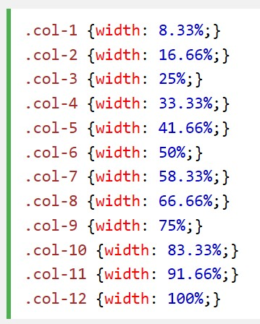

1. **CSS: All items should float left and have a padding of 15px.**
2. **HTML: Each row needs its own div. the number of columns inside a row should always add up to 12.**
3. **CSS: add style that clears the flow. This prevents elements moving as though the columns do not exist.**

**Media Queries – Responsive web design.**

**Uses @media rule to include a block of CSS properties only if a certain condition is met.**

@media only screen and (max-width: 768px) /* for mobile phones:/

{  
  body {  
    background-color: lightblue;  
  }  
}

* **Always design for a mobile first.**
* **This makes the page display faster on phones**
* /* For mobile phones: */  
  [class*="col-"] {  
    width: 100%;  
  }  
    
  @media only screen and (min-width: 768px) {  
    /* For desktop: */  
    .col-1 {width: 8.33%;}  
    .col-2 {width: 16.66%;}  
    .col-3 {width: 25%;}  
    .col-4 {width: 33.33%;}  
    .col-5 {width: 41.66%;}  
    .col-6 {width: 50%;}  
    .col-7 {width: 58.33%;}  
    .col-8 {width: 66.66%;}  
    .col-9 {width: 75%;}  
    .col-10 {width: 83.33%;}  
    .col-11 {width: 91.66%;}  
    .col-12 {width: 100%;}  
  }

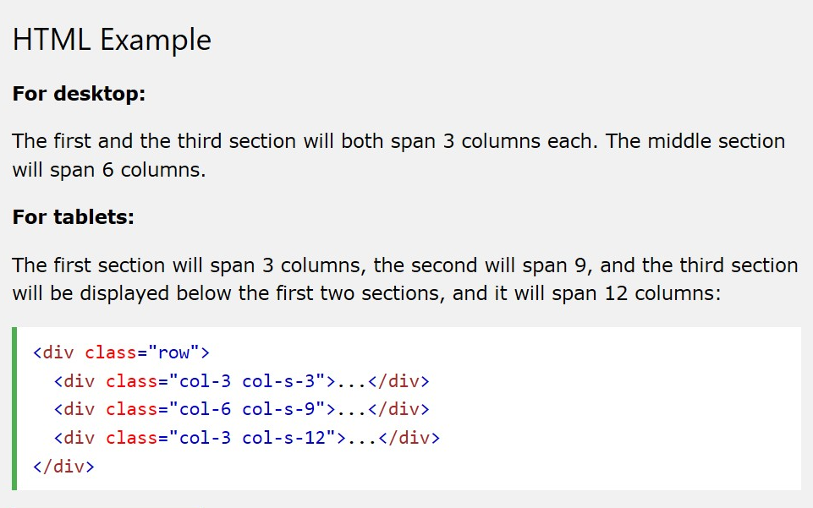

**Instead of targeting all of the different screen sizes: target:**

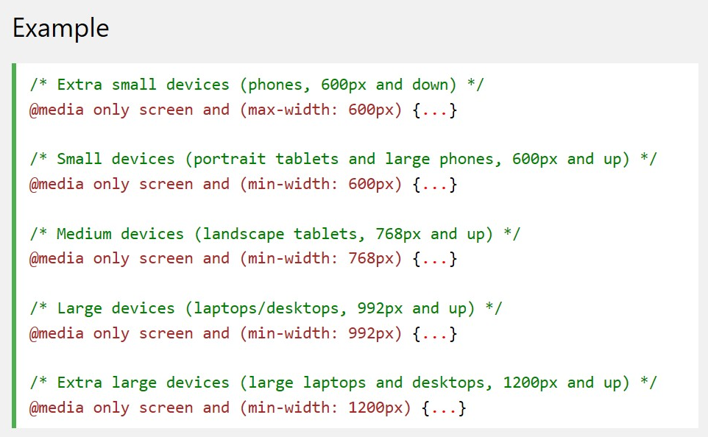

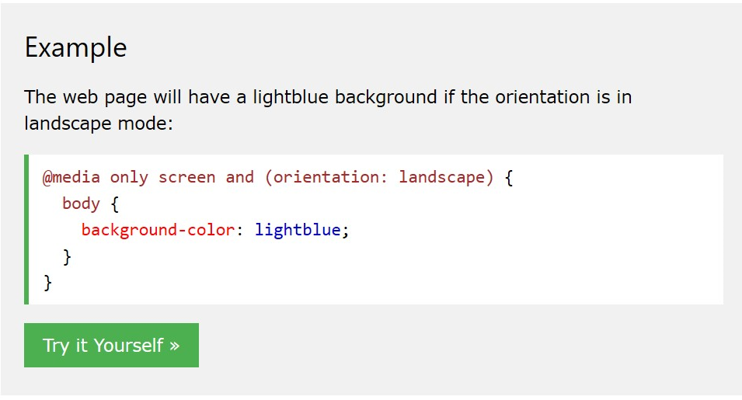

**Can also use media queries to hide elements or resize text.**

**Responsive web design – images**

**Use with: 100% and height: auto; this will make the image responsive.**

**Max-width: this means the image will never scale up but only scale down if it has to.**

1. If the background-size property is set to "contain", the background image will scale, and try to fit the content area. However, the image will keep its aspect ratio (the proportional relationship between the image's width and height): this can leave the background with white gaps

2. If the background-size property is set to "100% 100%", the background image will stretch to cover the entire content area: this changes the ratio of the picture.

3. If the background-size property is set to "cover", the background image will scale to cover the entire content area. Notice that the "cover" value keeps the aspect ratio, and some part of the background image may be clipped:

**Use media queries min-device-width instead of min-width to check the device width instead of the browser width. That way the image doesn’t have to change when resizing the browser window.**

**Use <picture> element. The first source that works for the media queries will display.**

**<picture>**

**<source srcset="img_smallflower.jpg" media="(max-width: 400px)">**

**<source srcset="img_flowers.jpg">**

**<img src="img_flowers.jpg" alt="Flowers" style="width:auto;">**

**</picture>**

* **The srcset sttribute is required, and defines the source of the image.**
* **The media attribute is optional and accepts the media queries you find in CSS @media rule**
* **You should also define an <img> element for browsers that do not support the <picture> element**

**Responsive web design- videos**

**Use width: 100%**

**Height: auto;**

**To responsively scale.**

**Use max-width to prevent scaling larger than the original size.**

**Grid layout module**

* **Has a parent element with one or more children**
* **Html element becomes a grid container when its display property is set to grid or inline-grid.**
* You can adjust the gap size by using one of the following properties:
* grid-column-gap  
  grid-row-gap  
  grid-gap

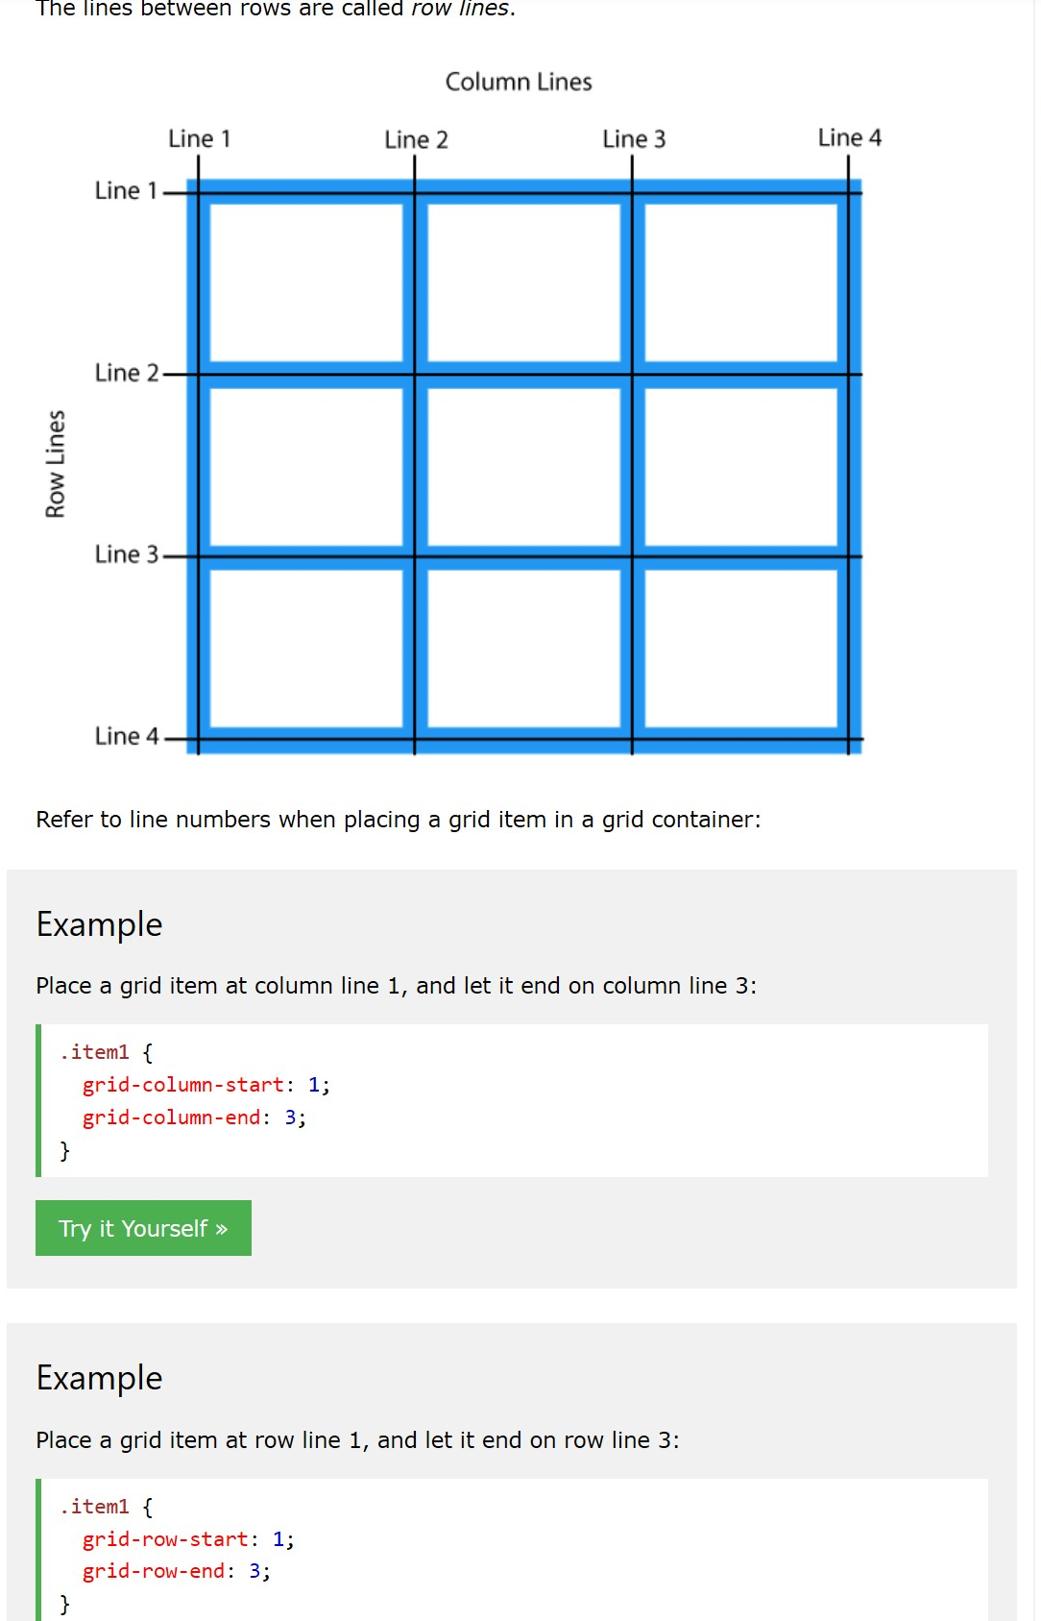

**Grid container**

**Grid-template-columns = defines the number of columns in the grid layout and the width of each. Each space between the number represents the width of the column. Use auto to make all the same width**

**Grid-template-rows= defines the height of each row. Each value is to each row.**

**Justify-content= aligns the grid inside the container. The total width has to be less than the container.**

**Align-content= vertically aligns the whole grid inside the container. Grid height has to be less than the container.**

**Grid item**

**Grid-column= states what column to place the item.**

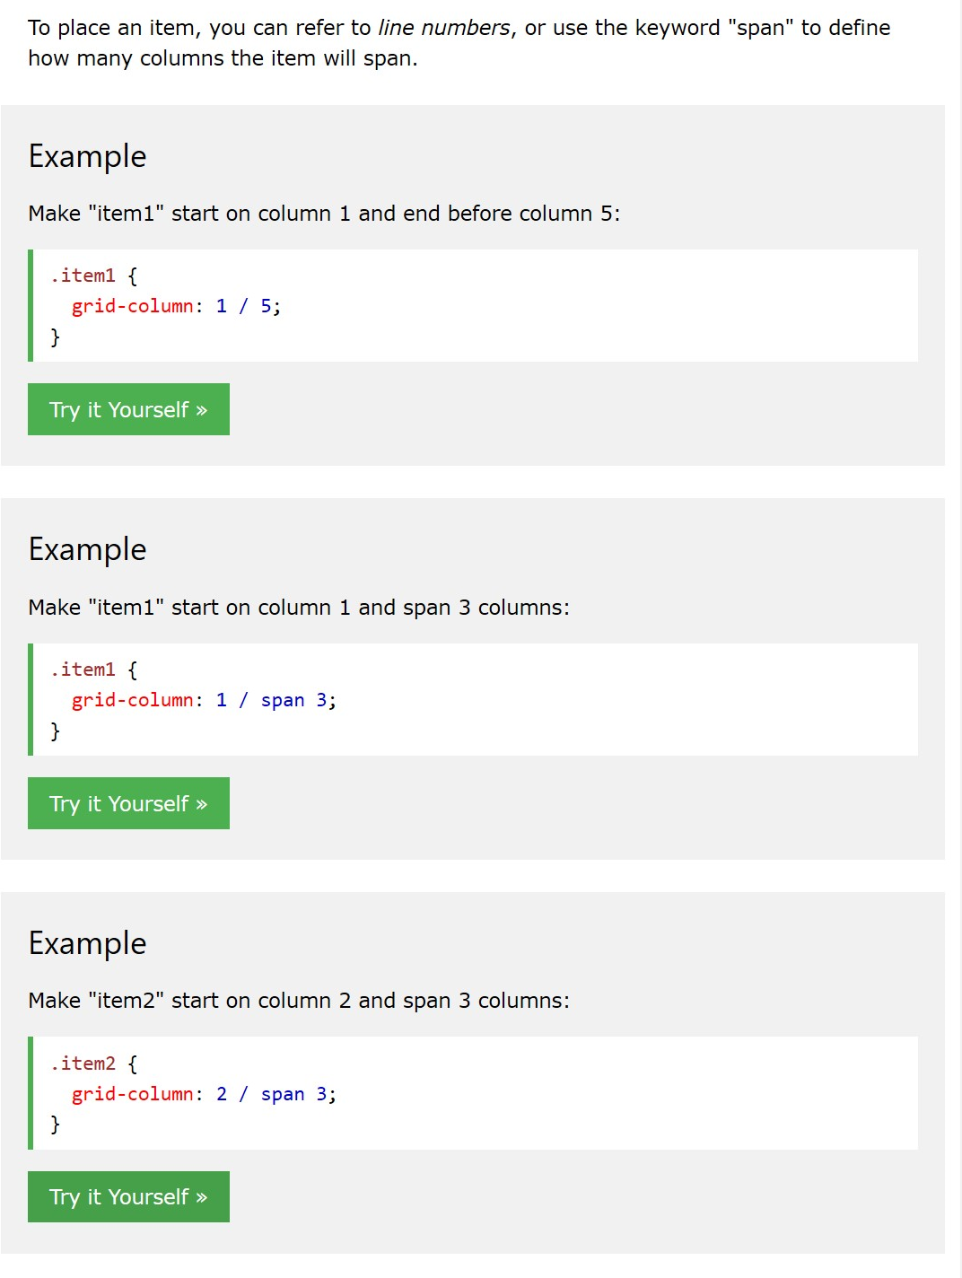

**The grid-row property defines which row to place the item.**

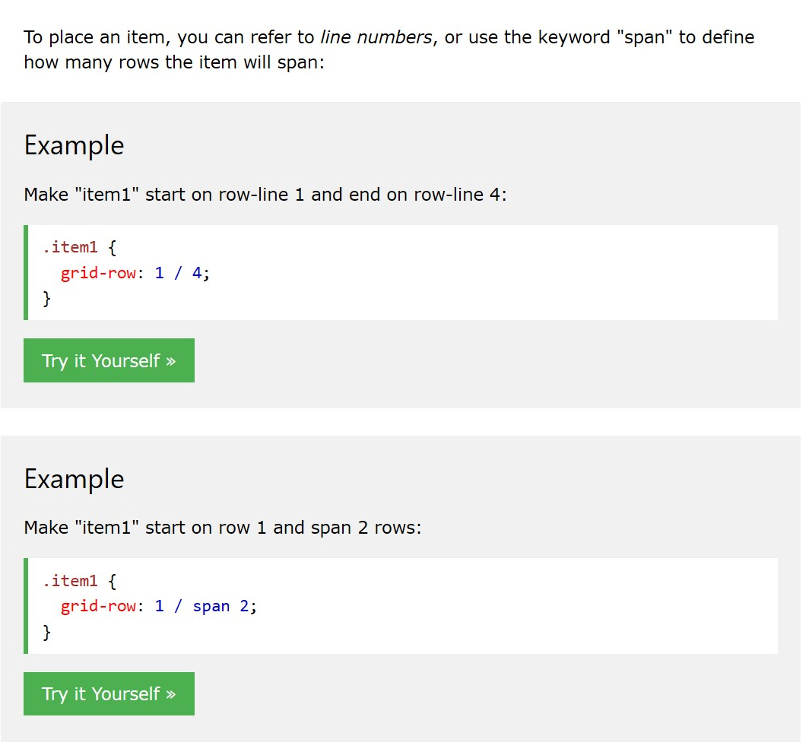

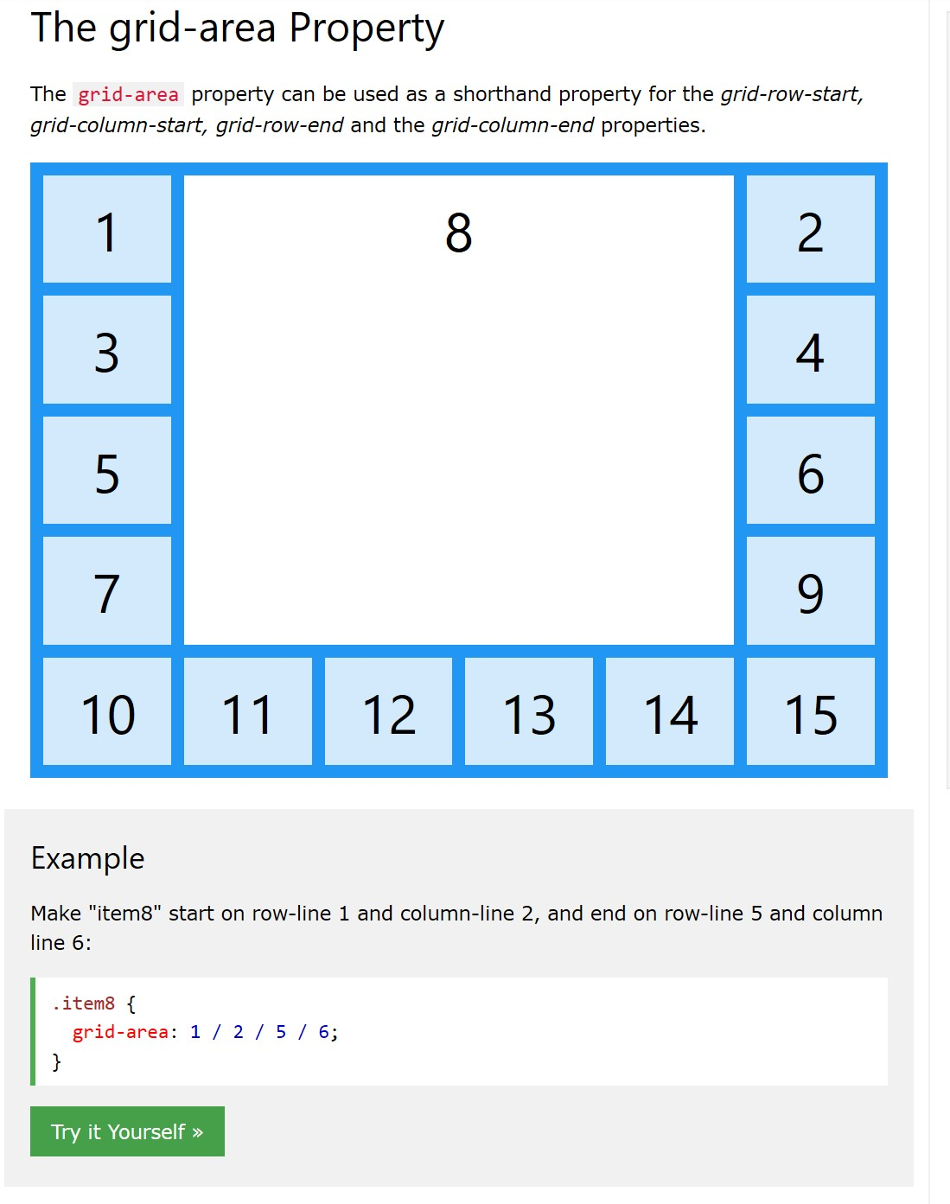

**Grid-area: row-line/ column-line/ end of row line/ end of column line;**

* **Can also be used to name items on a grid.**
* 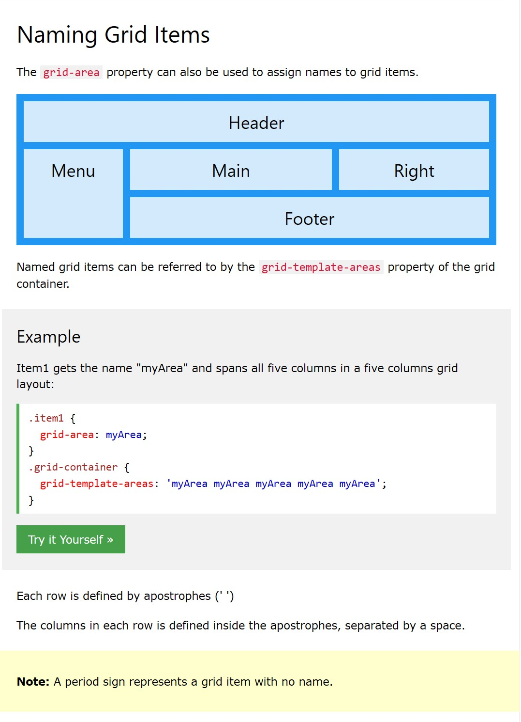

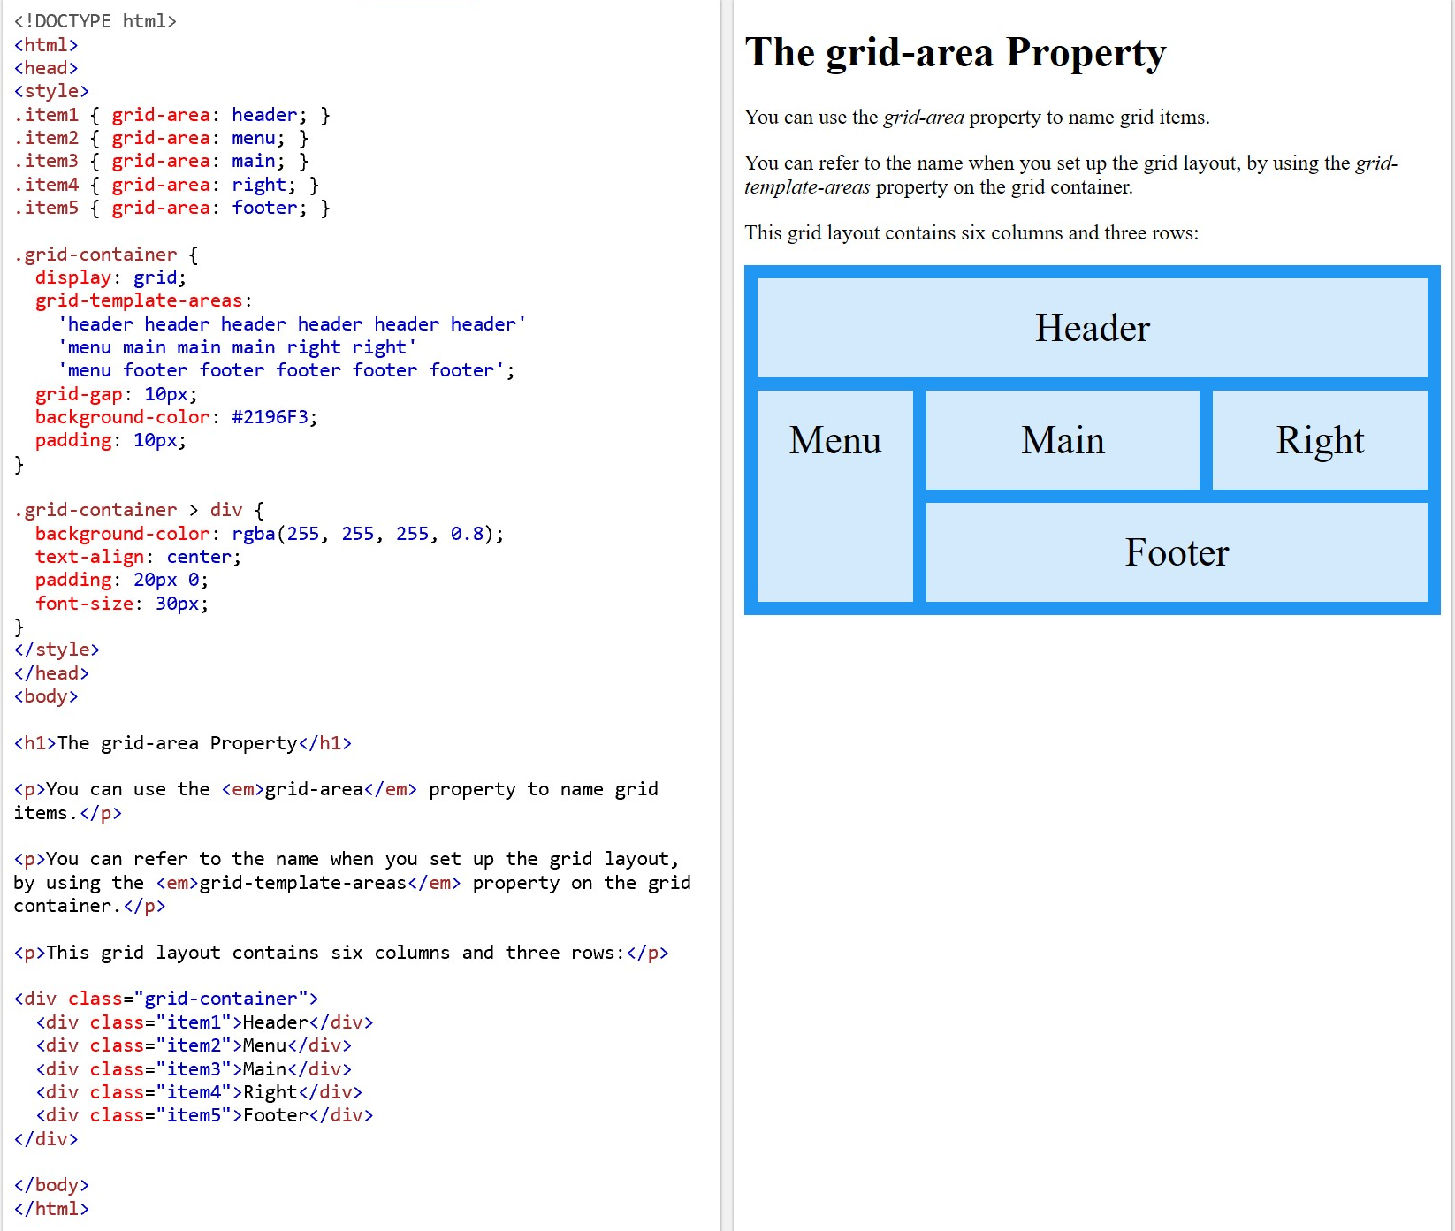

**Extra Notes:**

Sizes for screens:

/* Extra small devices (phones, 600px and down) */  
@media only screen and (max-width: 600px) {...}  
  
/* Small devices (portrait tablets and large phones, 600px and up) */  
@media only screen and (min-width: 600px) {...}  
  
/* Medium devices (landscape tablets, 768px and up) */  
@media only screen and (min-width: 768px) {...}  
  
/* Large devices (laptops/desktops, 992px and up) */  
@media only screen and (min-width: 992px) {...}  
  
/* Extra large devices (large laptops and desktops, 1200px and up) */  
@media only screen and (min-width: 1200px) {...}